Poudre Heights Filing 3

Homeowner Association

Single Family Homes Design Guidelines

TABLE OF CONTENTS

1. Landscape Improvements 3
1.1 Landscape Plan Submittal 4
1.2 Landscape Plan 4
Landscape Plan Checklist 5
1.3 Landscape Design Intent 6
1.4 Landscape Grading Requirements 6
1.5 Tree Planting Requirements 6
1.6 Turf Lawn 6
1.7 Planting Bed Recommendations 8
1.8 Landscape Features 9
1.9 Irrigation 9
1.10 Maintenance 10
1.11 Landscape Installation 10
  - Additional Landscape Design Recommendations 11
1.14 Specific Types of Improvements (Definitions) 12
2. Fence Design Criteria 18
2.1 Basic Criteria 18
2.2 Fence Design 18
  - Fence Design Between Lots 18
EXHIBIT A Address Plat / Lot Matrix 19
EXHIBIT B Fence Details 20

LANDSCAPE IMPROVEMENTS
Landscape improvements are an important factor in the streetscape, the architectural integrity, and the overall look and feel of Poudre heights Filing 3. A well-designed landscape program may be the most important value-enhancing element for the entire community. These landscaping guidelines have been carefully crafted to ensure that each home’s landscaping is a great amenity and will blend in with the surrounding neighborhood.

Any landscape construction within the community, including initial plantings, subsequent improvements, and drainage projects, must adhere to the following design standards and requirements. Prior to commencement of construction, written approval must be obtained through this review process.

All landscape construction that is to be undertaken in the community, whether original landscape plantings, subsequent landscape improvements, or any drainage improvement is subject to review under the following design standards and requirements. After completing this process and receiving written approval, construction may begin.

Design Review Committee (DRC) approval is required for all initial landscaping. Each homeowner shall complete a landscape plan, and this plan shall be submitted for written approval by the DRC within ninety (90) days of occupancy of the home. The landscaping plan must include a professionally designed landscape architectural plan that includes a professionally designed irrigation system. All drawings must be clear and concise, including the plot plan, showing all grading and swales, including adjacent lot landscape and drainage if grading is to be changed from previously approved plan, location of various trees, shrubs, flower beds, turf areas, walkways, berms, play areas, water features, etc., with types of plants intended for use clearly marked. All landscaping shall conform to the established development drainage pattern.

The Poudre Heights Filing 3 Board has the authority to remove, or arrange for removal, of any shrubs, plants, trees, gardens, swimming pools, playground areas, gazebos, water features, or similar structures that have not been approved by the Design Review Committee (DRC).

All owners, contractors, designers and any other designated representative shall comply with the following process in order to gain approval from the DRC for any landscape construction. Unless otherwise approved by the DRC, any lot on which a dwelling is completed shall complete the installation of the approved landscaping plan within 120 days after receiving DRC approval unless completion deadlines can’t be met, the homeowner/builder shall request an extension through the DRC. An extension request shall include reason(s) for the delay, a new timetable for completion. If installing a fence, this item must be included in your landscape plan.

Upgrades to existing landscaping (already approved by DRC) such as but not limited the addition of trees, shrubs, perennials etc. do not require DRC approval as long as the upgrades meet the intent of the guidelines. Major landscape improvements as well as upgrades or the addition of hardscape features requires DRC approval. As to whether the project does or does not require approval, the homeowner should submit a request to the DRC who shall make a determination. Certain fees associated with these types of projects may be waived by the DRC.

  - Landscape Plan Submittal

The homeowner/builder shall submit the Landscape Plan plus appropriate fees (contact the management company for current fee schedule).

The management company will submit the landscape plan to the DRC. The DRC will review the plan and will provide a written response no later than (thirty (30) days after the review. The written response will indicate approval of the plan, approval with modifications, or denial. If the plan is denied, a written response will be given explaining the reason for denial. The homeowner/builder is entitled to re-submit the plan to address the initial concerns without further fees and must do so within 45 days of denial or face a re-submittal fee. Any re-submittal shall follow the submittal procedures and address the areas of concern.

Additional fees may be required if the proposed landscaping plan modifies the previous grading and professional engineers or surveyors need to review the modified plan.

Construction must not begin prior to receiving a written approval from the DRC.

  - Landscape Plan

The following information must appear in the Landscape Plan:

- Lot, Block, Filing number and Owner’s name and address
- Designer’s name, address, and telephone number (if applicable)
- North arrow
- Landscape Plan Checklist shall be filled out and corresponding items shown to be shown on the Landscape Plan

Poudre Heights Filing 3 - Single Family Lot - Landscape Plan Checklist
Existing | Landscape Plan  (Filled out by Owner or Designer) | Landscape Review  (Filled out by Landscape Reviewer)
Address
Lot (Square Footage)
House
Property Lines and R.O.W.
Easements
Utility Lines
Drainageways
Driveway and Walkways
Landscape Improvements
Walls
Proposed

Lawn (Square Footage) not to exceed 40% of Lot Area
Bark Mulch
Rock Mulch
Walkways, Patios & Decks
Edging (concrete or metal)
Landscape Features*
Plant Material
Required Street Tree (name, size and location)
Trees, shrubs, ornamental grasses and perennials (name, size and location)
Grading and Drainage (if changes are to be made to grading and drainage)
Underdrain Locations
Sump Pump Discharge
Lighting
Irrigation
*All landscape features should also be shown on the plan with size, material, and appropriate details or cut sheets. Landscape features include walls, fences, vegetable gardens, hot tubs, pools, walks, patios, decks, gazebos, water features, boulders, structures, play equipment, basketball hoops, lighting etc. If any item will not be installed, the section may be filled in with Not Applicable.
APPROVAL STATUS / DATE:

  - Landscape Design Intent

With the understanding of the land and its characteristics in mind, it is the objective of this document and the DRC to establish not only a proper blend of residential structures but an adequate and diverse landscape pallet. It should be clearly understood that the requirements for a certain number of specimen trees and an increased pallet and number of landscape materials will collectively serve as a value creating thread throughout the entire community.

- The landscape concept should be refined and elegant, providing a high quality, manicured appearance, which harmonizes with the surrounding neighborhood and architecture. Special attention should be paid to earth forms, site drainage, soft scape plant forms and placement, hardscape materials and design, and ground plane treatments. The plan should include development of outdoor use areas and spaces through the use of landscape earth forms and plant massing. Separation and privacy can be attained through the use of landscape berms, plant groupings, screens and hedges.

  - Landscape Grading Requirements

- The Developer is responsible for the Finished Overlot Grade of the site. The builder is responsible for constructing the approval final grade, the site’s drainage and providing the certificate of drainage topographical accuracy. The home builder/homeowner/landscaper is responsible for maintaining the integrity of the grading which may have adjusted to comply with berming, retaining walls, drainage, and the landscape requirements of these design standards.
- Landscapers are not allowed to alter drainage or begin work without DRC approval of the landscape plan. The grade of the site should provide adequate drainage and be in accordance with the original plot plan.
- Coordination of landscape beds and turf areas must occur between surrounding properties in order to blend property lines and drainage patterns. These areas of existing landscaping must be shown on the landscape plan.
- All drainage must comply with the master drainage plan.

  - Street Tree Planting Requirements
- Street tree per lot
  - (1) one Shade / Canopy Tree, minimum1.5” caliper container or equivalent installed in accordance with Town of Windsor standards.
  - Ornamental trees shall be planted in substitution for shade trees where overhead utility lines and fixtures prevent normal growth and maturity of shade trees.
- Street Tree Placement
  - Wherever the sidewalk is attached to the street, shade trees shall be established in an area ranging from three (3) to seven (7) feet behind the sidewalk.
- Street Tree Clearances
  - No tree planting is to be made closer than ten (10) feet or one-half (1/2) of the mature canopy width from any building or structure.
  - Vehicular Sight Distance Triangle and Signage
    - At the intersection of streets, roadways or vehicular access points, no tree or plant material with a mature height greater than three (3) feet shall be planted within a sight triangle measuring forty (40) feet along the boundary of each of the intersecting streets, measured from the point of intersecting curb lines or edge of asphalt.
    - Deciduous trees may be permitted to encroach into the clearance triangle provided the lowest branch of any tree shall be at least eight (8) feet above grade.
    - When approaching traffic control signs, standard warning signs, and school signs, the sign shall be visible from the travel lane at a distance of 100 feet.
  - Street Light
    - 40’ for shade / canopy trees
    - 15’ for ornamental trees
  - Utilities
    - 10’ from wet utilities
    - 4’ from dry utilizes
    - Street trees on local streets planted may conflict with utilities within utility easements. Additional conduit may be required to protect underground electric lines.
  - Concrete
    - 10’ from driveway
    - 4’ from sidewalk
- Unless otherwise specifically authorized by the Town Forester, the following species and types of trees and woody plants shall not be planted or allowed to grow upon public street rights-of-way. Any of the poplar species (Populus spp.), including but not limited to cottonwood, aspen, silver poplar, or Lombardy poplar. Any of the willow species (Salix spp.) The box elder tree (Acer negundo) The Siberian elm (Ulmus pumila) Any weeping or pendulous type tree (i.e. weeping birch) Any tree with a bushy growth habit which cannot be maintained to a single leader or trunk. Any shrub or hedge which by its growth would obstruct, restrict, or conflict with necessary and safe use of the pubic rights-of-way. Conifers or evergreens which would eventually grow over the sidewalks or street. Any honeylocust (Gleditsia triacanthos) that bear either seed pods or thorns. Russian olive (Eleagnus angustifolia).

  - Turf (Lawn)

- Each home may incorporate a turf component into both the front and rear yards. Not to exceed 50% of the Landscape Area (excludes impervious areas like home, driveway, etc).

- Turf for the front yard must be installed in the form of sod (no seeding) and shall be a drought tolerant blend Texas hybrid bluegrass, fine leaf fescue, or a bluegrass/fescue blend.

- Turf for the rear and/or side yards may be installed in the form of sod or seeded using a high quality Kentucky Bluegrass, fine leaf fescue, and/or bluegrass/fescue blend.

- Metal or narrow concrete edging shall be installed around any turf area.

- Artificial turf is allowed in the rear yard but not permitted in the front or side yard adjacent to a public right of way.

- If trees stand alone in a turf area the base of the tree should be surrounded with mulch. Mulch will retain moisture and will allow easier maintenance around the tree trunk.

  - Planting Bed Requirements

- Planting beds shall comprise a minimum of 50% of the site excluding building footprint, driveway and hardscape. Lines of the planting beds should be defined by and in relation to berms, walkways, patios, other landscape elements, and planting beds on adjoining lots. In addition, most beds should serve a function such as foundation and utility screening, buffering for privacy, enhancement of views, defining outdoor spaces, wind block, sun block, or erosion control.
- If the adjoining home is landscaped or being planned, coordination of adjoining planting beds and tree locations is required to achieve a more unified and cohesive landscape expression. Individual site landscaping should be coordinated with existing common area landscaping. Concrete or metal edging may be required in these areas.
- The front entry and sides of the house should have significant foundation plantings that are complimentary to the architecture of the house. The rear area of the house should contain the outdoor use areas and have adequate screening to protect the privacy and view of the owner as well as the surrounding neighbors.
- Utility boxes, trash enclosures, pet enclosures, play equipment, swimming pools, tennis courts, hot tubs, and other such items shall be screened from adjoining residences, open space, and streets.
- It is required that planting beds utilize shredded wood or rock mulch at least 3” in depth.
- Because of the park-like settings and open feeling of Poudre Heights Filing 3, the home’s perimeter plantings should be developed with openings in the landscaping. A “wall” of vegetation, which encloses the whole lot, is unacceptable.
- Large expanses of mulch or bed areas in excess of 10 square feet without plantings are unacceptable.
- Small and medium shrubs, 2’ to 4’ in height should typically be planted 3’ on center and be 5-gallon size. These shrubs should be indicated on the plan as circles measuring 3’ to 4’ in diameter.
- Large shrubs, 5’ to 10’ in height should typically be planted 5’ on center and be either 5-gallon size or balled and burlapped. These should be indicated on the plan as circles measuring 5 to 6’ in diameter.
- The use of perennials to add color and texture to shrub beds is highly encouraged. They should typically be one gallon in size and planted in maximum distance of 18” on center. Perennials should be indicated on the plan as circles measuring 1’ in diameter. All perennials must be identified on the plan indicating quantities. If ground covers are used, they can be specified by flat. The minimum requirements are one flat of 32 plants per approximately 10 square feet of bed area.
- Staghorn or Smooth Sumac shall not be planted within 10’ of a property line.
- Large evergreens, including spruce and pine trees, at least 10’ from and or half the mature size, whichever is greater, the house and perimeter fences.

  - Landscape Features

Details of the following features must be submitted with the landscape plan and approved by the DRC prior to installation. See index specific requirements:
Fences Pools, hot tubs
Walls Play equipment
Structures Lighting
Bird Baths Water Falls
Large rocks Bird Houses
Dog runs Arbors, trellis
Ponds

  - Irrigation

The community is run on a non-potable water source with a fixed amount of water supply. The management company will provide a schedule for watering dates and restrictions. Xeriscape landscape design shall be applied in accordance with the Town of Windsor Code.

A professionally designed and installed automatic irrigation system is required for all residences and shall encompass all turf and planting bed areas. This will conserve water by allowing plantings with similar water requirements to be irrigated together.

Non-Potable Water Point of Connection Detail
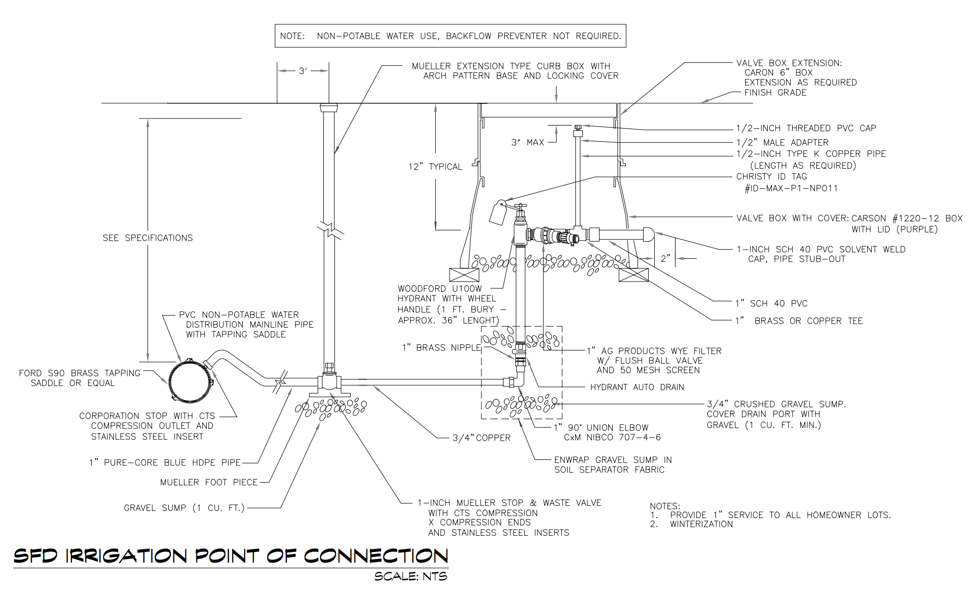

  - Maintenance

The trees, shrubs, and other landscaping materials located within required planting areas shall be considered binding elements of the project in the same manner as parking, building materials, and other details. The applicant, his successors, assigns, and/or subsequent owners and their agents shall be responsible for the continued maintenance of all landscaping materials.

All landscaping shall be permanently maintained in a neat and attractive condition with at least the same quality and quantity of landscaping as originally approved. Minimum maintenance requirements include watering, mowing, edging, pruning, removal and replacement of dead or dying pant material, elimination of weeds and undesirable grasses and removal of trash. Plant material which exhibits evidence of insects, disease, and/or damage shall be appropriately treated. Dead trees/plants shall be removed as soon as possible.

  - Landscape Installation

- Owners of lots shall cut and control all weeds and vegetation growing on all lots, whether vacant, occupied, or those with improvements under construction as well as control erosion and runoff of dirt and silt from the lot.
- Material staging and holding areas must only occur on the site where installation occurs. Under special circumstances a vacant lot may be used only with prior written permission from the lot owner.
- After installation, all materials must be cleaned up from the site, street and surrounding area. If any material is left on site, it will be disposed of and charged to the property owner.
- Landscaping must conform to the plan and meet the requirements of these guidelines. All stipulations and changes made during the approval process must followed.
- The DRC reserves the right to inspect the site during and/or after installation to insure that it conforms to the required design standards and approved plan. In the event that the installed landscape does not meet the required design standards and does not follow the approved plan, the DRC reserves the right to require the contractor or owner to correct any problems at the contractor’s or owner’s expense. The contractor/owner shall immediately correct any installation, which is not in conformance with the approved plans or face sanctions from the Board of Directors.
- In unusual or emergency like situations, a homeowner/builder may request, via the DRC, phasing the approved landscape plan over no more than two (2) growing seasons. In order for the DRC to approve phasing of landscaping, the homeowner/builder must meet the following:
  - Have an approved landscape plan
  - Justify the request
  - Submit a refundable fee (refundable if the original plan is deemed completely installed)
  - All turf, mulch, edging, trees, and other plants in containers larger than 1 gallon must be installed as originally prescribed in these guidelines. This requirement will allow the home to have a vast majority of landscaping installed.
  - Perennials and the like (in containers 1 gallon or less) may be installed during the second growing season but must be completed no later than September 30.

  - Additional Landscape Design Recommendations

- Use plant materials that produce different effects at different times of the year so that the landscape will have interest during each season is encouraged.
- In large shrub beds, plant groups of shrubs and perennials in like groupings (for example: a minimum of 3 of the same shrub and 5 of the same perennial should be planted together) as this will create more of an impact on the landscape.
- Design beds so that small areas of turf, less than 3 feet in width, are not created.
- Design in elevation as well as plan view. Use the architectural elevations in conjunction with proposed landscaping to determine what plant massing, height, and density would work best to enhance and compliment the architecture.
- Whenever possible, located trees in planted beds.
- Group plants with similar water requirements so that the irrigation system can be adjusted to specific zones.
- Design with perennials and annuals to add additional color and texture to the landscape. Use low to medium height perennials along walkways and patios. Use medium and large perennials in masses at perimeter plantings.

  - Specific Types of Improvements

1.14.1 General. Following is a listing, in alphabetical order, of restrictions as well as a wide variety of specific types of improvements which homeowners typically consider installing, with pertinent information as to each. UNLESS OTHERWISE SPECIFICALLY STATED (SEE SECTION 3.2), DRAWINGS OR PLANS FOR A PROPOSED IMPROVEMENT MUST BE SUBMITTED TO THE DESIGN REVIEW COMMITTEE AND THE WRITTEN APPROVAL OF THE DESIGN COMMITTEE OBTAINED BEFORE THE IMPROVEMENTS ARE MADE. In some cases, where it is specifically so noted, a homeowner may proceed with the improvement without advance approval by the Design Review Committee (DRC) if the homeowner follows the stated guideline. In some cases, where specifically stated, a type of improvement is prohibited. Any improvement not listed below requires DRC approval.
1.14.2 Balconies. See Decks
1.14.3 Basketball Backboards, Portable and Permanent Backboards. DRC approval is required for every free-standing, pole mounted basketball goal. Basketball courts are not allowed. Portable basketball hoops are allowed but must be stored when not in play.
1.14.4 Birdbaths. DRC approval is not required if placed in "rear" yard and of a height not greater than 3 feet including any pedestal. Placement in "front" or "side" yard requires DRC approval.
1.14.5 Birdhouses and Birdfeeders. Committee approval is not required for "rear" yard installation of two birdhouses and/or birdfeeders, Size is limited to 1 x 2 feet. Additional units or location in "front" yard requires DRC approval.
1.14.6 Clothes Lines and Hangers. Cloths lines or clothes drying structures require DRC approval.
1.14.7 Compost. DRC approval is not required. Container must be screened and shall not be immediately visible to adjacent properties and odor must be controlled. Underground composting is allowed. The installation of the containers must conform with municipal regulations.
1.14.8 Decks. DRC approval is required. Must be wood, composite, iron or other material similar to the material of the residence and, must be painted or stained in a color similar to or generally acceptable as complementary to the residence. Elevated decks require a masonry component on columns or posts, and must be a minimum of 16" x 16" or 12" diameter. Covered decks shall use the same roofing materials and must be installed as an integral part of the residence and patio area. Decks must be located so as not to obstruct or diminish greatly the view of adjacent property owners or to create an "unreasonable" level of noise for adjacent property owners. Construction shall not occur over easements and must be set back in accordance with the set back requirements in the Covenants.
1.14.9 Dog Runs. DRC approval is required. Considerations shall include, but not be limited to, location in “rear” or “side” yard and abutting the home, proximity to neighbor's residence, “screened” from view, type of cover if utilized, limited in size to 250 square feet, and shall match the style and color of the perimeter fence. If a cover is used, the cover type and materials used must be addressed in the request for approval, generally tarpaulins are not approved. "Dog kennels" are not allowed. An approved wireless and/or underground electric fence may be approved by the DRC provided that the design and material meets the approval of the DRC.
1.14.10 Drainage. DRC approval is required for any change affecting drainage. The Covenants require that each lot owner be responsible for providing adequate water drainage from the lot into existing storm drains or street gutters so that water does not drain onto adjacent lots. The established drainage pattern as engineered and constructed by the Developer/Builder prior to (or in some cases, immediately following) conveyance of title from the Developer/Builder must not be interfered with, except as approved in writing by the DRC. When installing landscaping, it is very important to insure that water drains away from the foundation of the house and that the flow patterns prevent water from flowing under or ponding near or against the house foundation, walkways, sidewalks and driveways. Water shall flow over walkways, sidewalks or driveways into the street. The DRC may require a report and drainage certification from a civil engineer as part of landscaping or improvement plan approval. Landscaping shall conform to the established drainage pattern. Sump pump drainage shall be vented a reasonable distance from the property line to allow for absorption on the lot.
1.14.11 Extrior Lighting. Any additiona to the orAny addition to the original exterior fixtures (garage, front and rear doors) must be approved by the DRC. Note: Builders and home owners may not install accessory lighting without proper approval and authorization. . DRC approval is required to change or add exterior lighting. Therefore, the use of motion detector spots, spotlights, flood lights or ballasted fixtures (sodium, mercury, multi-vapor, fluorescent, metal halide, etc.) require DRC approval. Considerations shall include, but not be limited to, the visibility, style and location of the fixture. Exterior lighting for security and/or other uses must be directed towards the ground and house whereby the light cone stays within the lot boundaries and the light source does not cause glare to other homeowners (bullet type light fixtures are recommended.)
1.14.12 Fences.
  - General Statement: Fences and/or walls constructed by the Developer or Builder along or abutting property lines, arterial streets, collector streets, and local streets shall not be removed, replaced, painted a different color or altered, including adding a gate, without approval of the DRC. If any such fences and/or walls constructed by the Developer or Builder which are located on a homeowner's property are damaged or destroyed by the homeowner, then the homeowner shall repair or recondition the same at homeowner's expense.
  - Perimeter lot fencing shall be permitted. Fences that are presently permitted are perimeter, tot lots and dog runs. DRC approval is required of all fencing (see Exhibit "B" (in Landscape Design Guidelines for open rail fence design)
  - Pre-approved Fence Design: Perimeter fence. Tot lots and dog runs, planned to be located in the rear or side yards along property lines (not previously installed by Developer) must be constructed and stained exactly in accordance with the specifications shown on the Poudre Heights Filing 3 Homeowner Fencing Plan and Details attached to these guidelines. DRC approval of the location of the fence is required prior to installation by submitting a professional sketch, using the site plan of the home site showing the fence line and gates and any variations in height. Fencing shall be set back a minimum of eight (8) feet from the front of the house.
  - Maintenance and Staining: Regular physical and aesthetic maintenance of fencing is required. The maintenance of the home site side of fencing installed by Developer between greenbelts and lot lines becomes the responsibility of each homeowner sharing that fence portion. The Association and or District shall maintain the greenbelt side of shared fences. Stone columns shall be maintained by the Association and or District, however, the home owner is responsible for any damage done by homeowner. Staining of all fences must be done with the approved stain for Poudre Heights Filing 3. See Fencing Plan and Details document.
1.14.13 Firewood Storage. See Wood Storage
1.14.14 Gardens – Flower & Vegetable. DRC approval is required. A landscape plan including the location of the gardens must be submitted. All gardens must be weeded, cared for and carefully maintained.
1.14.15 Gazebos. DRC approval is required. Must be an integral part of the landscape plan and must not obstruct adjacent property owners' primary views.
1.14.16 Grading and Grade Changes. See Drainage
1.14.17 Greenhouses. DRC approval is required. Approval will be based upon, but not limited to, general aesthetics, quality and permanence of materials used. Adequate screening will be required.
1.14.18 Hanging of Clothes. See Clothes Lines and Hangers
1.14.19 Hot Tubs. DRC approval is required. Must be installed on a concrete pad. Must be 7 feet from property lines. Must be in the rear yard. Must be installed in such a way that is not immediately visible to adjacent property owners and in a manner that it does not create an unreasonable level of noise for adjacent property owners, and must be screened from adjacent property owners with landscaping.
1.14.20 Irrigation Systems. All lawns shall have an automatic irrigation system approved by the DRC and shall be submitted in conjunction with the landscape plan. No underground manual irrigation system will be approved. All irrigation must be professionally designed and installed. Overspray from irrigation systems shall not encroach onto other properties.
1.14.21 Jacuzzi. See Hot Tubs
1.14.22 Kennels. Not allowed. See Dog Runs and Definitions.
1.14.23 Latticework. DRC approval is required for any type of trellis or latticework.
1.14.24 Lights and Lighting. See Exterior Lighting
1.14.23 Patio Covers. DRC approval is required. Must be constructed of wood or material generally recognized as complementary to the home and be similar or generally recognized as complementary in color to the colors in the home. Free-standing patio covers shall be permitted as well as extensions of the roof.
1.14.24 Patios - Enclosed. See Town of Windsor Code
1.14.25 Patios - Open. DRC approval is required. Must be an integral part of the landscape plan and must be located so as not to create an unreasonable level of noise for adjacent property owners. Must be similar or generally accepted as a complementary color and design of the residence.
1.14.26 Paving. DRC Approval is required, regardless of whether for walks, driveways, patio areas or other purposes and regardless of whether concrete, brick, flagstones, stepping stones, pre-cast patterned or exposed aggregate concrete pavers are used as the paving material.
1.14.27 Play and Sports Equipment. DRC approval is required if equipment is more than six feet in height. All playground equipment must be located from rear and side home site lines a minimum distance equal to the tallest height of the equipment, but not less than 10 feet. All playground equipment is required to be of wood construction and must be stained with the same color specification as used for the fencing throughout the subdivision. Absolutely no metal play equipment shall be permitted. All slides, canopies, and covering for play-sets and swings must be earthtones and compatible with colors of the exterior of the home.
A playground area shall be designated on the approved landscaping plan for construction of play equipment such as swing sets and playhouses. (This designation allows neighboring homeowners to plant screening landscape features.) Moveable/temporary play equipment less than 5' in height must be placed/stored out of view from adjacent properties. Consideration shall also be given to securing lightweight play equipment, which is subject to movement by high winds.
For trampoline requirements, see trampolines.
1.14.28 Playhouses. DRC approval is required. If structure is more than 24 square feet or over six (6) feet high, it shall be considered an accessory building. See Town of Windsor Code for Accessory Buildings.
1.14.29 Poles. See Basketball Backboards, Birdhouses, etc.
1.14.30 Pools. DRC approval is required. Pool equimpnet must be fully screened and must not exceed 50 decibels. Supporting documentation regarding decibel level must be provided at submittal. Decibel level may be verified by a 3rd party as needed, at the owner’s expense. See Landscape/Fence Design Guidelines Section 4.7.4 for pool screening.
1.14.31 Saunas (Exterior). DRC approval is required.
1.14.32 Spas. See Hot Tubs
1.14.33 Sprinkler Systems. See Irrigation.
1.14.34 Statues. DRC approval is required. It is recommended to install all statues in the rear yard and of a height not greater than 5 feet, including any pedestal.
1.14.35 Storage Sheds. See Accessory Buildings in Town of Windsor Code.
1.14.36 Sunshades. See Overhangs.
1.14.37 Swing Sets. See Play and Sports Equipment.
1.14.38 Trampolines. Trampolines must be placed in the backyard of a property, and must be set back a minimum of 10' from all property lines. Trampolines must be buried at ground level, must be screened and hidden from all adjoining properties and must be firmly anchored to the ground for wind protection. Safety and liability are the homeowner's responsibility.

1.14.39 Walls. See Fences.
1.14.40 Walls - Retaining. DRC approval is required. Walls shall not void reasonable fencing of property lines, nor disturb certified drainage plans and be constructed of a material which complements the architectural materials of the house.
1.14.41 Wind Turbines, Wind Vanes, Wind Chimes, Directionals, etc. DRC approval is required.
1.14.42 Wood Storage. DRC approval is not required provided that the wood is located in the backyard, adjacent to the house; must be neatly stacked; must be screened from neighbor's view and must not be located so as to block any existing drainage pattern on the site.

FENCE DESIGN CRITERIA

2.1 Basic Criteria:

The Developer of Poudre Heights Filing 3 installed an open rail fence system on the perimeter of the development that shall not be removed by a homeowner and must be maintained and repaired by the homeowner if damaged by them. A fence damaged during construction of a home, must be repaired by the contractor.

A homeowner will be allowed to install one (1) gate into the fence at the rear of the lot for access to open space. The gate must be no wider than 4-feet and must match the existing fence design.

2.2 Fence Design:

Refer to Exhibit B for detail.

- Fence shall be constructed of high-quality cedar fencing material
- Posts shall be 4” round with no more than 4-feet exposed above the ground. Posts shall be cemented in place (2’ deep)
- Fence shall be composed of 2 rails using 3” round rails (generally 8-feet long)
- Each post shall extend above the top rail
- New fencing shall match existing fencing as it relates to height of posts and placement of rails. Refer to existing neighborhood for fencing for guidance.
- A homeowner whose dogs and the like use the rear yard must install 14 gauge galvanized welded wire fence in PVC-coating (also referred to as 2 x 4 woven wire fabric). Additionally, the use of 1 x 2 woven wire fabric may be used to keep rabbits and other small animals out of the garden.
- The wire shall be attached to the lot interior of the cedar fence and shall not extend above the top rail but can extend below the bottom rail.

2.3 Fence Design Criteria for fencing between lots:

While not required, homeowners who choose to install fencing between individual lots and on sides of a house shall follow the fence design criteria noted above.

The homeowner may install one (1) gate on each side of the home and must be the design criteria noted above.

EXHIBIT A

Add lotting plan with address or lot and block with corresponding lot square footages or an address / lot square footage matrix.

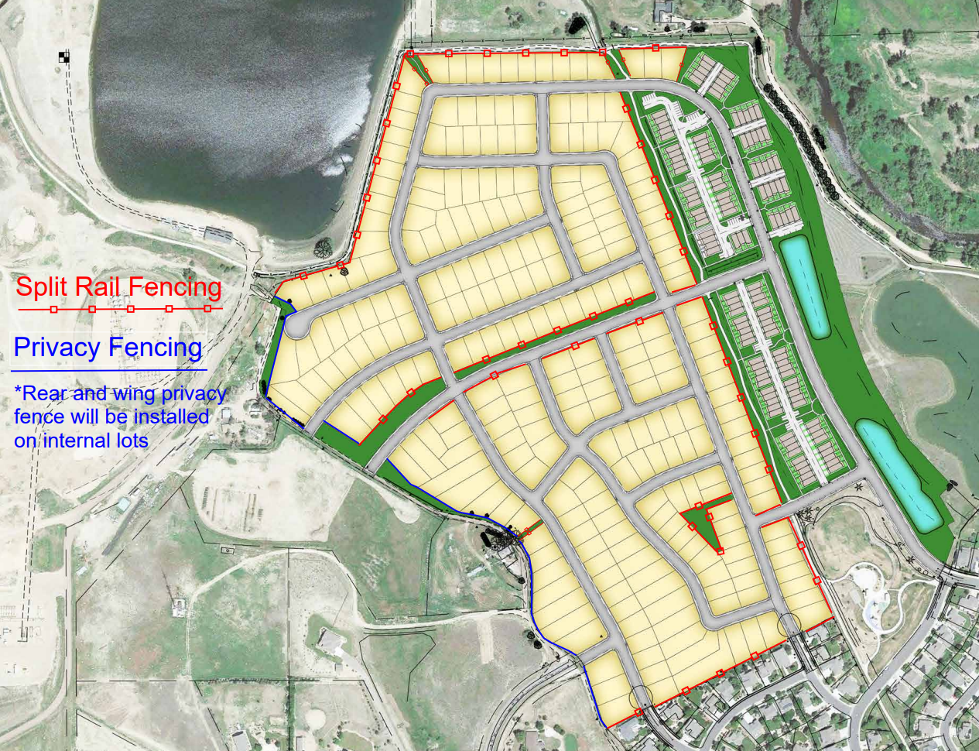

EXHIBIT B

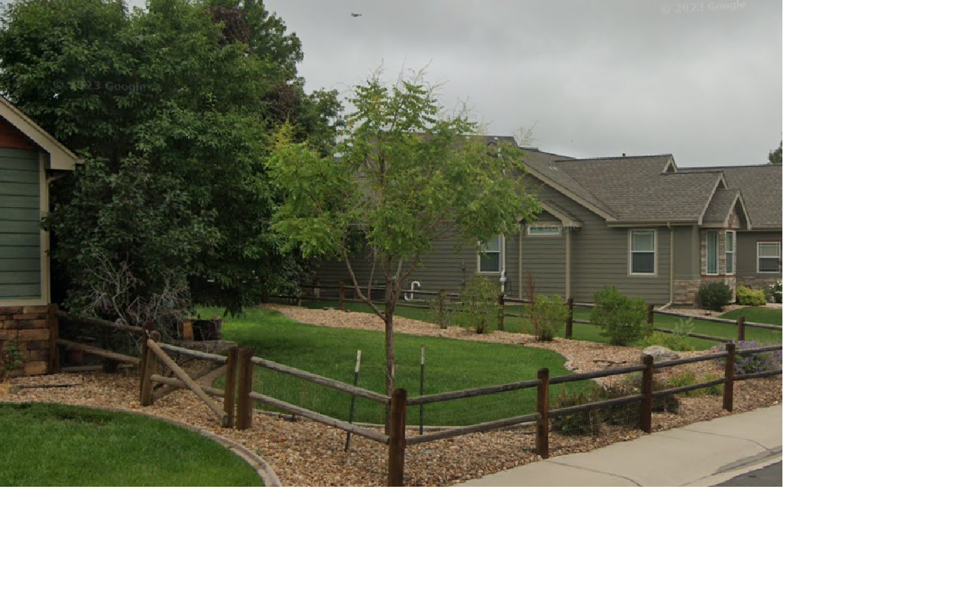
Existing fence shown for reference while we finalize the detail.

